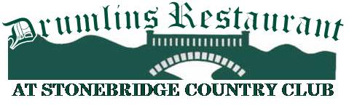

Starters

Bavarian Pretzel Cigars $8
Warm Bavarian pretzel served with Pub mustard or warm beer cheese dipping sauce.
Tavern Wings or Boneless Wings $15 / $12
Choice of Buffalo, BBQ, Sweet Chili, or Korean BBQ and Habanero sauce side of ranch or blue cheese
Cheese Quesadilla $9
Corn tortilla filled with cheddar jack cheese served with sour cream and salsa add chicken $3 or beef $4.
Fried Pickle Chips $8
Sliced dill pickles battered and deep fried served with a Sriracha Ranch dipping sauce.
Baked Garlic Knots $6
Pizza dough brushed with garlic butter and baked served with horseradish bacon crème.
Corn Dogs $6
Just like the state Fair with Pub mustard dipping sauce
Salads
Garden salad $6/$10
Mixed greens, tomato, cucumbers, red onions, and carrots
Caesar Salad $6/$12
Romaine lettuce Classic dressing Parmesan cheese and croutons
Stonebridge Chopped Salad $14
Assortment of meats and blue cheese crumbles mixed greens tomato cucumbers and red onions
Creamy Italian, Caesar, Blue Cheese or Balsamic Dressing
Add chicken $4 or beef $6.

Sandwich
Roasted Turkey$12
Roasted white meat turkey served with lettuce tomato and mayonnaise.
Drumlins Burgers $15
8oz of fresh steak burgers on toasted Brioche with lettuce, tomato, red onion, and choice of cheese
America Cheddar Swiss Provolone cheese
Add bacon $2.
Stonebridge Cheese Steak $14
Thinly sliced beef and Provolone cheese on A Hoagie roll
Add peppers or onions $1.
Chicken Caesar Salad Wrap $12
Grilled chicken Romaine lettuce and Caesar dressing
Choice of French fries Cole Slaw or Side salad or Onion rings $3
Wheat Bread, wraps, Brioche Bun or Hoagie roll.

Entrees
Club House Sirloin $18
12oz New York strip steak grilled to your liking served with Fries and side salad.
Grilled BBQ Chicken $16
Grilled chicken breast glazed with house made BBQ sauce served with fries and Cole slaw.

Be sure to check the daily specials.
consuming raw or uncooked food increase the risk of food borne illness.

